
Cheetah Xpress Track Club
ATHLETE APPLICATION FORM
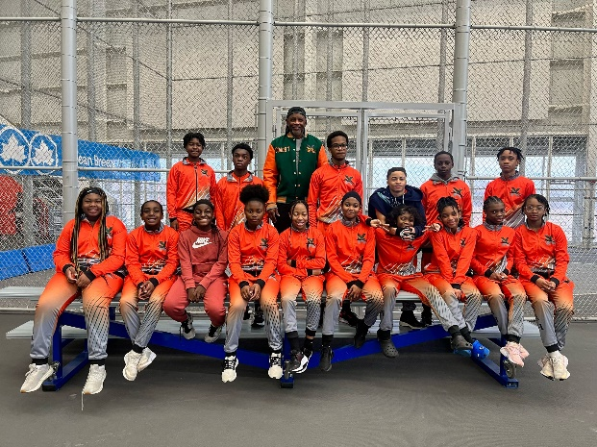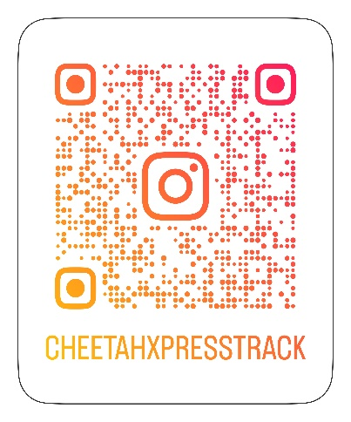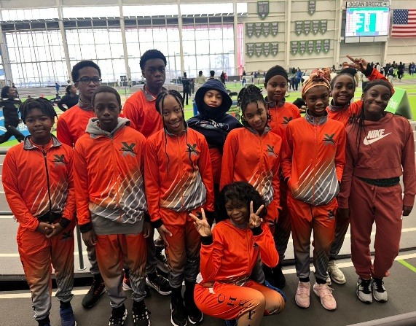
February 2024 Track and Field Meet Link to Instagram Page February 2024 Track and Field Meet Ocean Breeze Ocean Breeze
Coach Troy Pittman: 754-779-0229
Team Practice: At least Four Times Weekly -
(Linden Park – Linden Blvd. and Vermont Street and
(I.S. 218- 370 Fountain Avenue, Brookly, NY)

(REGISTRATION FEE: $450 per season – includes uniform)

PLEASE PRINT CLEARLY
Please Indicate Your Interest: ☐ Track ☐ Field ☐ Both Track and Field
Parent/Guardian First and Last Name: _____________________________________________________________
Relationship: ____________________________________________________________________________________
Athlete’s First and Last Name: _____________________________________________________________________
Preferred Nick Name: ____________________________________ Gender: ☐Male ☐Female ☐ Other
Date of Birth _________________ __________________________________ Age:____________
Mailing Address: _________________________________________________________________________________
Home Address (if different from mailing address): ___________________________________________________
Parent/Guardian Telephone Number: ______________________________________________________________
Athlete’s Telephone Number (if applicable):________________________________________________________
Email Address: __________________________________________________________________________________
Current School: _________________________________ Current grade level: ____________________________
Have you ever run track before: ☐ Yes ☐ No
If Yes, When, Where, How Long: ___________________________________________________________________
_________________________________________________________________________________________________
Emergency Contact Name, Telephone Number and Relationship: _________________________________________________________________________________________________
Does your athlete play any other sports? ☐ Yes ☐ No
If yes, please list all sports, team name and location: _______________________________________________
_________________________________________________________________________________________________
_________________________________________________________________________________________________
Reason for joining Cheetah Xpress Track Club ( please do not leave blank ): _________________________________________________________________________________________________
_________________________________________________________________________________________________
_________________________________________________________________________________________________
Please list previous injuries including dates (i.e.: sprains, fractures surgeries, etc.): ___________________
_________________________________________________________________________________________________
_________________________________________________________________________________________________
Please list any current medical conditions: _________________________________________________________
_________________________________________________________________________________________________
Does your child suffer from Asthma? ☐ Yes ☐ No
Athlete’s last medical/physical date: _______________________________________________________________
Physician’s Name and Telephone number: ________________________________________________________

Parent/Guardian Name (please print): _____________________________________________________________
Parent/Guardian Signature: _______________________________________________________________________
Date Signed: _____________________________________________________________________________________
* Please note: A recent physical no older than one year is required upon joining the team.

